Guidelines for Sustainable Business Travel

The Trials Methodology Research Partnership (TMRP) is committed to making a positive environmental impact by promoting sustainable business travel. The purpose of these Guidelines is to encourage and support a reduction in the carbon impact of essential TMRP business travel, and to reduce non-essential TMRP business travel. The guidelines apply to TMRP staff, stakeholders and students.
Examples of business travel include, but are not limited to:

- Attendance at conferences/workshops, such as ICTMC.
- Academic meetings.
- Fieldwork (for research).
- Delivering a talk or lecture.
- Delivering or receiving a course/training.
- Administrative and business meetings (inc. committees, governing body meetings).
- Fundraising activities and initiatives.
- Recruitment of University staff.
- Student examinations (e.g. PhD viva examinations).
- Student activities (e.g. trips made by TMRP DTP students)
- Overseas assignments.

Equality and inclusivity
By helping to reduce the need or expectation for an individual to travel for work purposes, the Guidelines support inclusion of those who cannot travel for reasons of health, mobility, caring responsibilities etc., and those who choose not to fly. At the same time, however, the aim of the Guidelines should be to reduce TMRP business travel in a way that does not discriminate against or disadvantage any individual, and to provide equality of opportunity for all.

Background
The term “climate conscious travel” was first developed by the University of Edinburgh. It is achieved when the travel choices that staff and students make as part of their day-to-day work and study are informed by the environmental impact that they have, and preference is given towards virtual collaboration and lower carbon travel modes. With climate conscious travel in effect, the environmental cost of travel is prioritised over the financial cost and individual convenience, but not over individual safety considerations.
Modes of Transport
When it is essential to travel, TMRP stakeholder, staff and students should prioritise available modes of travel that have the lowest carbon impact. The carbon efficiency of different modes of travel is shown in the travel hierarchy shown below:
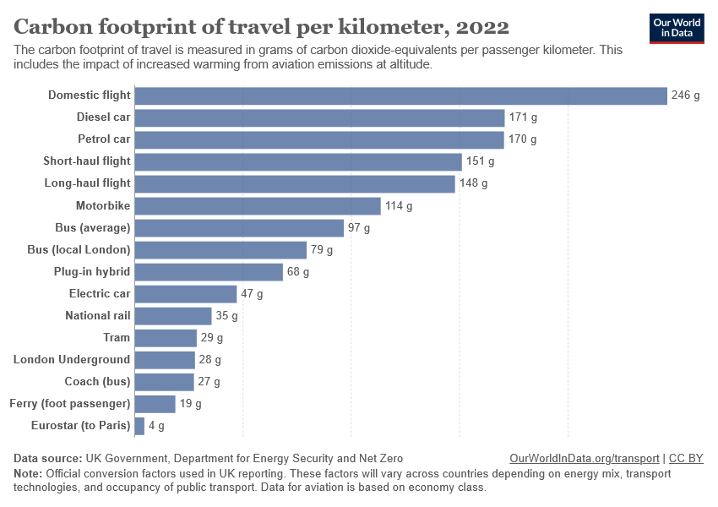

TMRP stakeholders, staff and students are strongly encouraged to follow the principles below:

a. For local and national travel, where available, public transport should be chosen over car use. If you need to use a (non electric) car for all or part of your journey, you will need to provide a rationale to the TMRP in advance.
b. For national travel, train and/or other public transport should be chosen over air travel. Attending conferences, workshops, or events that do not require air travel should always be considered, and more environmentally sustainable modes of public transport must be considered before flights.
Train travel (including Eurostar and other international rail) should be chosen over air travel for travel to all European destinations that can be reached within 6 hours from London terminals.
If a flight is deemed necessary, this request must be reviewed in advance by the TMRP.
For the flight to be approved you must fill in a flight request form and provide a rationale as to why the flight is needed for your trip. This statement must include the following:
- Details of the flight, including a description of the journey and event.
- Evidence to show that other modes of transport are not feasible or in line with this policy.
- Justification of how the event you are travelling to contributes to your research and/or will benefit TMRP.
In addition to this, we are strongly encouraging all to explore additional activities that could be tagged to the main event, maximising the benefits of in-person attendance.
There may be exceptional circumstances when it is not possible for an individual to follow the above principles, which may include:

- Safety considerations (e.g. in some countries/regions public transport may not be sufficiently safe).
- Caring responsibilities, where a longer time away would mean you are unable to make the trip.
- When following the sustainable business travel guidelines would be detrimental due to disability or health conditions.
- When contractual obligations from external partners (e.g. funding bodies) make following the travel expectations impossible.

In these circumstances, this information will need to be provided in advance in order for non-public transport to be funded by TMRP.
All flight requests should be emailed to the TMRP Coordinator Dr Kerrie McGiveron kerriemc@liverpool.ac.uk

Expenses
TMRP stakeholders, staff and students may claim additional subsistence expenses (accommodation, food and drink) when travelling by a less carbon-intensive mode necessitates more travel time. An example would be booking an overnight sleeper train.
We also encourage TMRP stakeholder, staff and students to consider low-carbon transport modes for longer journeys (>6 hours) but should use their judgement to determine what total journey duration is appropriate for their purposes and constraints.

For all queries please contact TMRP Coordinator and DTP Manager Dr Kerrie McGiveron kerriemc@liverpool.ac.uk

